The fate of organic pollutants in the subsurface and groundwater at the field scale during storms and irrigation events
Shulamit Nussboim, Lea Wittenberg, Elazar Volk, Jonathan B. Laronne, Felicia Orah Rein

Appended material

Research data are available at the bottom. Link to https://github.com/ShulamitNussboim/Flowpaths_Kishon_Public

or original files and codes

Appendix 1- Sampling locations and methods

A1. Sampling campaign

Table S1: Storms and irrigations sampling campaigns Winter 2022
Storms | Sampling date | Irrigation time/ Storm dates | Analysis
1st irrigation | 27-29/4/2021 | 27/4 at 10 AM- 28/4 at 10 PM | nutrients, pesticides, sediments
2nd irrigation |  | 20/6 at 9:00 AM -21/6 at 9:00 AM | nutrients, sediments
1st storm | 16/1/2022 | 14-16/1/2022 | nutrients, pesticides, sediments
2nd storm | 27/1/2022 | 23-30/1/2022 | nutrients, pesticides, sediment

Table S2: Sampling campaign location and date of collection. Compare locations to Figure S1-S2.
Location¹ | Stream | Field | Drainage  channels | Subsurface | Groundwater | Comments
1st storm (16/1/2022)
S | 12/1 |  |  |  |  | stream
S1 | 16/1 |  |  |  |  | stream
SP2-1 |  |  |  | 12/1 |  | west pipe*
WM1  (WWM) |  |  |  | 16/1 |  | most west Manhole (West West)  ~400 m from the stream
EF1 |  | 16/1 |  |  |  | surface runoff
EF3 |  | 16/1 |  |  |  | surface runoff
EF4 |  | 16/1 |  |  |  | surface runoff
EF2 |  |  | 16/1 |  |  | secondary channel
EF5 |  |  | 16/1 |  |  | secondary channel
EF6 |  |  | 16/1 |  |  | primary channels
EF7 |  |  | 16/1 |  |  | primary channels
WF8 |  | 16/1 |  |  |  | surface runoff
POWF14 |  | 16/1 |  |  |  | surface runoff, onion field (flooded area)
CWF15 |  | 16/1 |  |  |  | surface runoff, cotton field
WF10 |  |  | 16/1 |  |  | secondary channel
EM |  |  |  | 25/1 |  | East Manhole (manhole 3)
WPzD, WPzSH |  |  |  |  | 23/1 | **West piezometers are deep and shallow  East piezometer deep and shallow
EPzD, EPzSh |  |  |  |  | 23/1
2nd storm (27/1/2022)
S2 | 27/1 |  |  |  |  | stream
EF1 |  | 27/1 |  |  |  | surface runoff
EF4 |  | 27/1 |  |  |  | surface runoff
EF3 |  | 27/1 |  |  |  | surface runoff
EF2 |  |  | 27/1 |  |  | secondary channel
EF5 |  |  | 27/1 |  |  | secondary channel
EF6 |  |  | 27/1 |  |  | *** primary channels
PEF6 |  |  | 27/1 |  |  | additional water sample in EF6
EF7 |  |  | 27/1 |  |  | primary channels
WF8 |  | 27/1 |  |  |  | surface runoff
WF9 |  | 27/1 |  |  |  | surface runoff
WF10 |  |  | 27/1 |  |  | secondary channel
WF12 |  |  | 27/1 |  |  | secondary channel
POWF14 |  | 27/1 |  |  |  | surface runoff, onion field
WF15 |  | 27/1 |  |  |  | surface runoff
WF16 |  |  | 27/1 |  |  | secondary channel
WF17 |  |  | 27/1 |  |  | secondary channel
2WF18 |  |  | 27/1 |  |  | primary channel
WM2 (WM) |  |  |  | 3/2 |  | West Manhole
WPzD, WPzSH |  |  |  |  | 27/1 | ****West piezometers deep and shallow  East piezometer deep and shallow
EPzD, EPzSh |  |  |  |  | 27/1
SP2-2 -SP2-7 |  |  |  | 22-27/2 |  | *****West pipe outlet (6 sequential samples)

¹ S-; SP2-West pipe; EF- East field; WF- West field OWF14-runoff from onion plot; CWF15-runoff from cotton plot; WF10, WF12- Secondary channels (wheat plot); WF16, WF17- Secondary channel draining both onion and cotton plots; WF18- Primary channel (common to onion and cotton); 2WM- second west manhole, most western manhole; WM-western manhole; EEM- Most eastern manhole; WPzSh- West shallow piezometer; EPzSh-East shallow piezometer. P prefix- a substitute sample collected from nearby water after runoff stopped or if the sample was empty/lost. *Subsurface pipe outlet taken 4 days before it was submerged in storm **No groundwater was measured in the 1st storm. For comparison with data from the 1st storm, the first day of the groundwater campaign, taken three days after 1st storm, to be representative of 1st storm groundwater concentrations. This was the first day of the groundwater campaign. ***Almost full of sediments, water was sufficient only for pesticide analysis (insufficient for nutrients). **** The groundwater campaign overlapped the 2nd storm to investigate the storms' direct effect on groundwater quality. ***** before, during, and after the storm on 25-27/2 (total rain depth 14 mm).
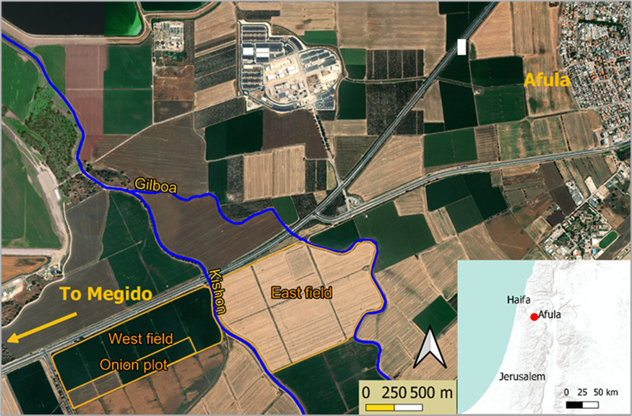
Figure S1: The study area of the East and West fields adjacent to the Kishon stream. The onion plot is located inside the West field. The map inset shows the regional location with the study area (red circle).

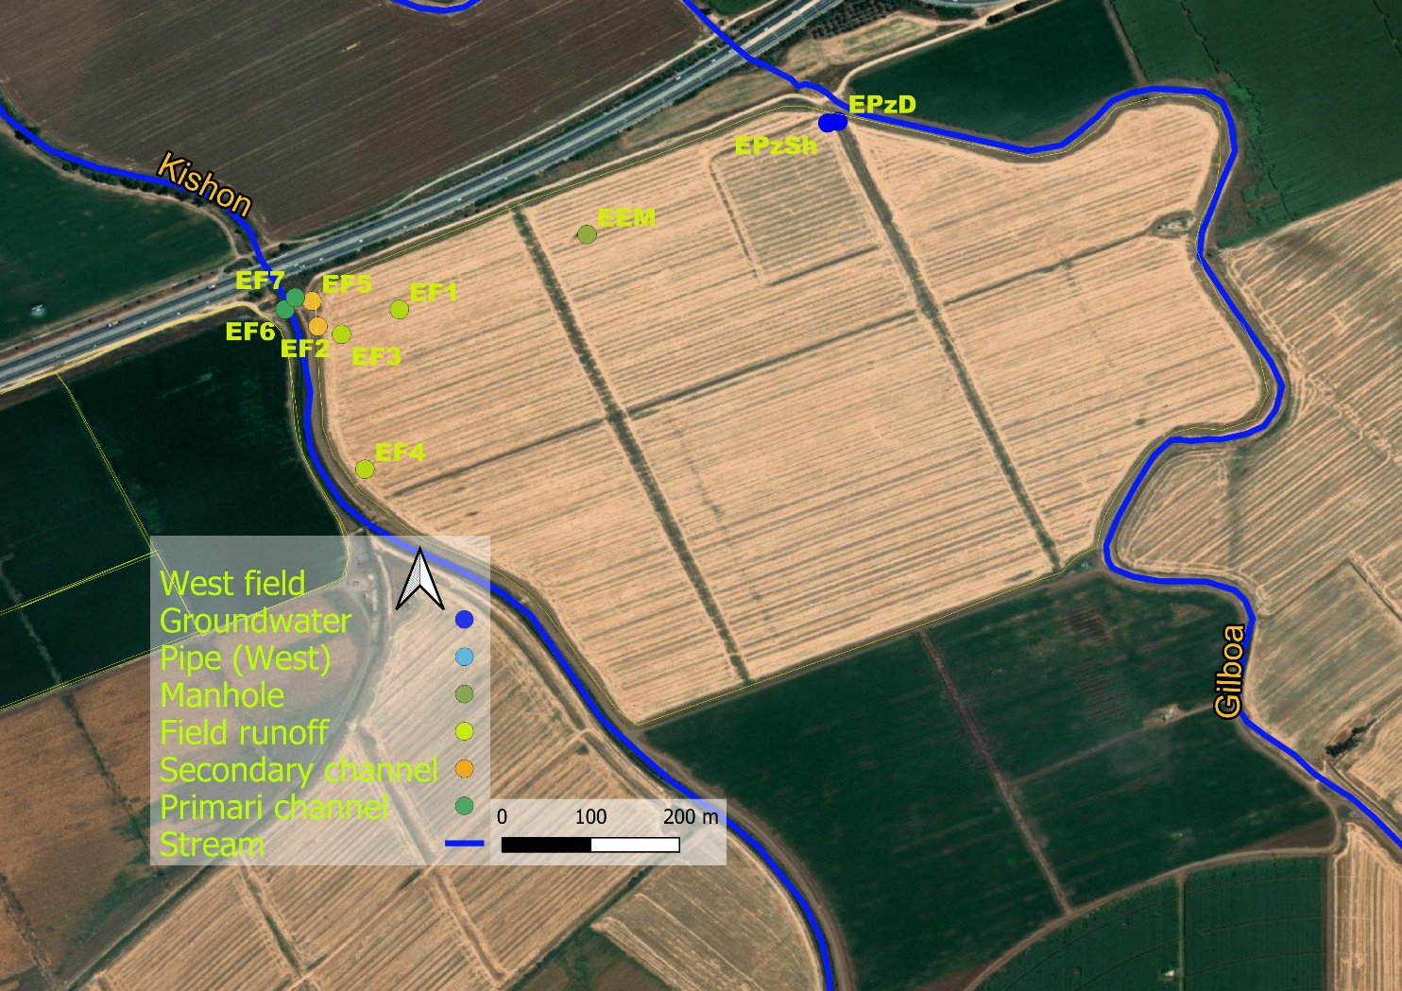
Figure S2: East field locations.
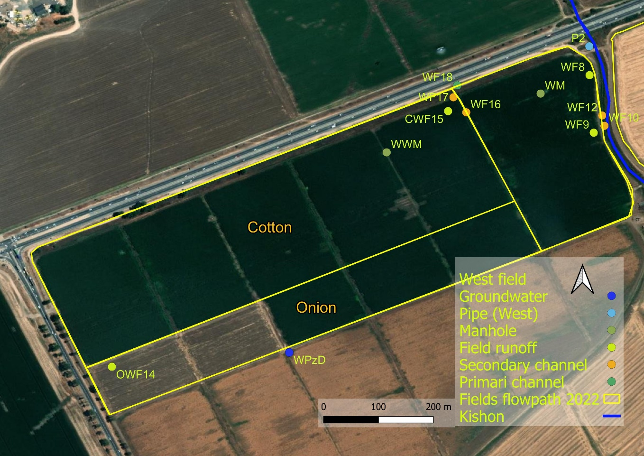
Figure S3: West field locations.

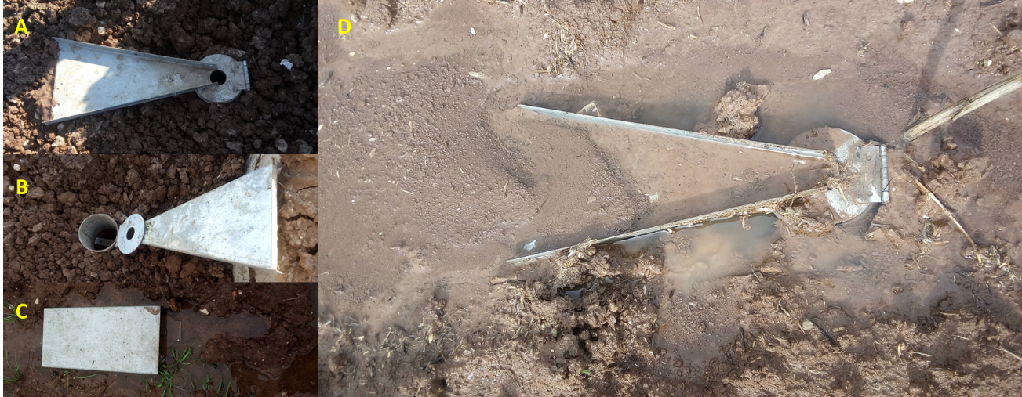
Figure S4: RCU (A) installed before rain; (B) RCU with flume open. The glass bottle is inserted into the designated cylindrical space; (C) Ready for the storm, RCU with the roof protecting rain dilution; and (D) RCU after removing the roof to collect the full sample.

Appendix B- Results
Table S3: This table defines the dominant flowpaths for each compound according to maximum detected concentrations (conc.). It also includes the highest concentration during the 28-29/4 irrigation event as a separate category. The Farmers' application timing, including the last application date, is defined for 15 relevant compounds. ES/ED- East shallow/deep piezometers; WS, WD- West shallow/deep piezometers. n.d. -not detected. Bromacil, naproxen, and ibuprofen were added only in winter 2022 to the analyzed compounds. Where no application dates are available, it is assumed that the compound had not been applied since 2/2020 in the East field and as of 11/2012 in the West field.

Name of organic compound | Max conc.  in winter 2022 (ng/L)  + location | Max concentration in irrigation  (ng/L) | Concentration (ng/L) in groundwater+location | Date of last application by the farmer  (E-East field,  W-west field) | Number of samples it was detected in winter 2022 (of total 64)
Acetaminophen* | 1308  2nd West manhole | n.d. | West piezometers only  17.34 WS |  | 9
Acetamiprid | 1.5 West Primary channel | n.d. | West deep piezometer  0.39 | 16.6.2016 W | 11
Ametryn | 1.27  West shallow piezometer | 1.49 | Deep and shallow East piezometers, Shallow West piezometer 1.37 WS | 14.6.2015 W | 18
Atrazine | 31 West manhole | 219.07 | All piezometers  3.87 WD | 9.12.2020 W | 33
Atrazinen desethyl | 127 West manhole | 623.37 | None |  | 20
Atrazine desisopropyl | 86 West manhole | 312.16 | None |  | 17
Azoxystrobin | 7.87 West field onion runoff | 2.4 | All piezometers  1.85 WD | 7.7.2019 W | 53
Bezafibrate* | 21.6 East field runoff | n.d. | None |  | 4
Boscalid | 302 East filed, West field onion runoff | 45.75 | All piezometers  17.31 WS |  | 50
Bromacil | 46.5 West pipe outlet | n.d. | None |  | 11
Caffeine | 2799 West field runoff | 1190 | All piezometers  620 ED |  | 35
Carbamazepine* | 1421 West West manhole | 884.11 | All piezometers  119 ED |  | 63
Carbamazepine 10,11n.d.epoxide | 305 West manhole | 175.91 | Shallow East piezometer, West deep piezometer 8.87 ES |  | 48
Carbamazepine  2 hydroxy | 4.8 East field primary channel | 173.08 | None |  | 3
Carbamazepine  trans- 10,11-dihidroxy | 68 2nd West Manhole | 173.08 | East shallow piezometer only 12.34 |  | 24
Carbendazim | 14 West deep piezometer | 0.23 | All piezometers 13.95 WD |  | 38
Carbofuran | 0.51 West deep piezometer | n.d. | West deep piezometer 0.51 |  | 1
Chlorantraniliprole | 1475.7 Onion plot runoff | 539.01 | West deep piezometer 8.94 | 19.7.2019 W | 33
Cyproconazole | 31.2 East field secondary channel | n.d. | None | 8.6.2018 W | 4
Diazinon | 0.64 East deep piezometer | n.d. | East deep piezometer, West piezometers 0.64 ED |  | 9
Diclofenac* | 12.72 West field secondary channel | n.d. | East shallow and West deep piezometers 3.58 WS |  | 5
Difenoconazole | 17.12 West field runoff | n.d. | All piezometers  5.71 WS | 14.3.2018 W | 45
Diflufenican | 6585 West field onion runoff | n.d. | All piezometers  0.65 ES, WS |  | 25
Dimethomorph cis/trans | 6.17 East field secondary channel & West field deep piezometer | n.d. | West deep piezometer 6.17 |  | 7
Diuron | 98996# East field runoff | 4.93 | All piezometers 123 ED | 17.2.19 W  30.12.21 E | 62
Fenaminphos sulfoxide | 636 West field secondary channel | 1.43 | None |  | 25
Fenaminphos | 28.2 West field primary channel | 12.65 | None |  | 4
Fenhexamid | 19.8 2nd West Manhole | n.d. | None |  | 1
Fluometuron | 12 Pipe outlet | 12.65 | Shallow East, deep West piezometers 3.16 ED |  | 21
Flutriafol | 0.45  West shallow piezometer | 7.5  Ponding water | West deep piezometer 0.45 |  | 1
Hexazinone | 1.2 West manhole | 1.55 | None |  | 4
Ibuprofen* | 571.7 West pipe outlet | n.d. | None |  | 7
Imidacloprid | 10621.2# West field onion runoff | 66.97 | All piezometers  15.28 ED, WD |  | 44
Indaziflam | 1.21  East primary channel | n.d. | None |  | 2
Lamotrigine* | 130  West manhole | 79.23 | East and West shallow piezometers 11.11 WS |  | 42
Metalaxyl | 36.98 East field secondary channel | 7.2 | All piezometers  1.44 WD |  | 62
Metazachlor | 7.65 West pipe outlet | n.d. | None |  | 1
Methomyl | 3.91 West field onion runoff | n.d. | None |  | 1
Methoxyfenozide | 971 2nd West manhole | 1379.8 | All piezometers  5.64 ES | 30.6.2020 W | 55
Metolachlor | 92 West shallow piezometer | 40.24 | All piezometers  92 WS | 11.3.2020 W | 63
Metribuzin | 8 Onion plot runoff | n.d. | 2.48 WD | 11.11.2019 W | 2
Naproxen* | 5 East deep piezometer | n.d. | East deep piezometer 4.97 |  | 1
Oxadiazon | 10808.9# West field onion runoff | n.d. | None | 10.1.2022 W | 13
Penconazole | 5.8 East field secondary channel | 6.39 | East shallow, West deep, and shallow piezometers  2.92 WD |  | 16
Pendimethalin | 11574# West field onion runoff | n.d. | All piezometer  1.15 WS | 20.2.16 W | 35
Pirimicarb | (Only in irrigation) | 1.08 | None
Prochloraz | 0.5 Subsurface West pipe outlet | n.d. | None |  | 1
Prometon | 0.4 West manhole | 0.58 | None |  | 3
Prometryn | 1.52 Subsurface west pipe outlet | n.d. | West shallow piezometer  0.92 |  | 7
Propachlor | 0.06 East shallow piezometer | n.d. | East shallow piezometer  0.06 |  | 1
Propamocarb | 57.91 West deep piezometer | n.d. | All piezometer  57 WD |  | 63
Propazine | (Only in irrigation) | 2.47 | None
Propiconazole | 7.3 East field runoff | n.d. | West shallow piezometer 1.85 |  | 2
Propoxur | 367.3 West West manhole | 526.89 | All piezometers  22.59 ED |  | 43
Propyzamide | 93.6 East field secondary channel | n.d. | West piezometers  15.24 WS | 12.2.2018 W | 17
Sildenafil*,** | 139.96 West field primary channel | n.d. | East deep piezometer  21.16 |  | 3
Simazine | 7.38 West deep piezometer | n.d. | West deep piezometers 7.38
Sulfamethoxazole | 1.87 2nd West manhole | 17.34 | None |  | 1
Sulfapyridine* | (Only in irrigation) | 0.59
Tebuconazole | 42.5 West field onion runoff/East file secondary channel | 16.12 | All piezometers  18.54 WD | 11.5.2018 W | 51
Tebuthiuron | 1.6 2nd West Manhole | 1.99 | None |  | 8
Terbutryn | 79.15 West shallow piezometer | 10.23 | All piezometers  9.27 WS |  | 50
Thiacloprid | 0.82 West field onion runoff | n.d. | None |  | 2
Triadimenol A | (Only in irrigation) | 14.75, ponding water |  | 16.6.16 W | 0
# Measured concentrations were very high. Actual concentrations were higher than reported; *- Pharmaceuticals (rather than pesticides);
**- data contain significant errors for these compounds.
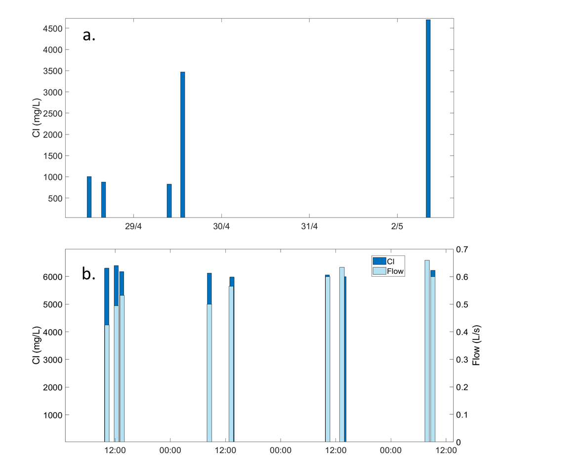
Figure S5: a. Chloride concentrations on the first irrigation event (April 2021). b. Chloride and water flow during irrigation on June 2021

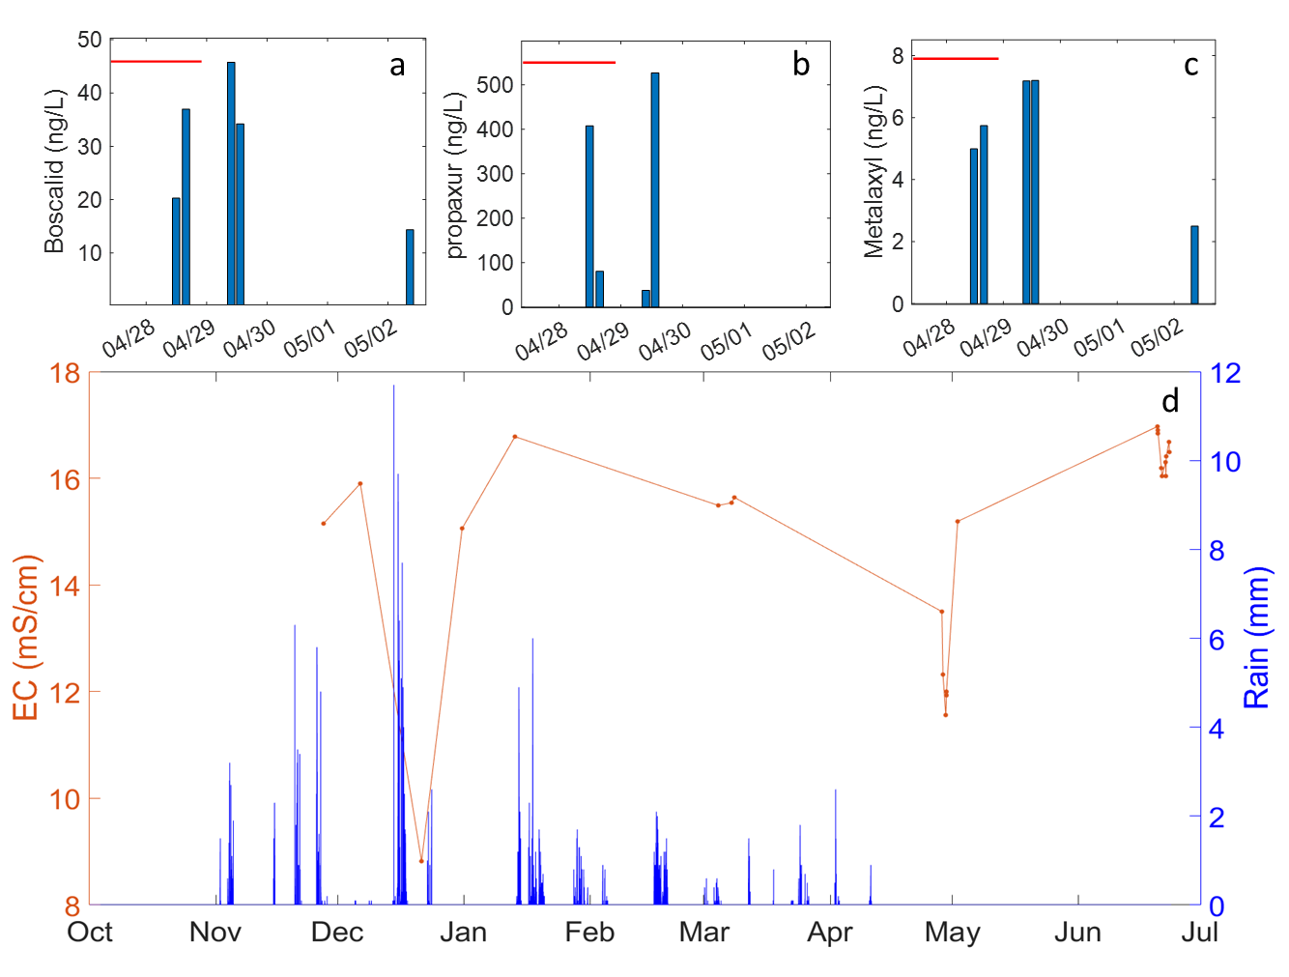
Figure S6: a-c: Boscalid, propoxur, and metalaxyl concentrations (ng/L) during and after irrigation on April 28-29, 2021. The red bars stand for the duration of irrigation. d: Measured EC (mS/cm) during winter 2021 and spring 2021. The orange line illustrates the trend of EC, with markers indicating the times at which measurements were taken, while the blue bars represent rainfall. EC decline in irrigation is shown on 28/4-2/5 and 20-22/6.

Table S4: Application dates of analyzed compounds in the West field, ordered by first application date. Onion in parentheses states application in onion plot (contained carrot or tomatoes for some years).
West field | dates
Diuron | 21/09/2015, 29/09/2015, 1/10/2015, 17/02/2019
Ametryn | 14/06/2015
Pendimethalin | 20/02/2016 (onion), 10/1/2022 (onion)
Propyzamide | 02/03/2016, 12/02/2018
Acetamiprid | 22/05/2016, 16/06/2016
Triadimenol | 16/06/2016
Metolachlor | 12/02/2018, 11/03/2020
Terbutryn | 15/01/2018
Difenoconazole | 14/03/2018
Chlorantraniliprole | 14/03/2018, 12/06/2019 (onion), 26/06/2019 (onion)
Tebuconazole | 11/05/2018
Cyproconazole | 14/06/2018
Methoxyfenozide | 23/05/2019, 30/06/2020
Imidacloprid | 30/06/2019 (onion), 22/11/2022 (onion)
Azoxystrobin | 23/10/2019, 07/07/2019
Metribuzin | 11/11/2019
Atrazine | 09/12/2020
Oxadiazon | 12/12/2021 (onion), 10/1/2022 (onion)
Diflufenican | 10/01/2022 (onion)
East field
Diuron | 30/12/2021

Table S5: Average concentrations in surface runoff and subsurface constituting the upper level water of subsurface and groundwater, respectively. Data measured in the West field: average over drainage channels and field surface runoff provide the average runoffconcentration, and the average subsurface data by WM, Second WM and SP2-1 provide the average subsurface for storms. Standard deviation of each average is given parenthetically. Koc values are from databases, where given, or average for given range of Koc. n.d.- not detected.
 | Average surface runoff concentration in West field  (ng/L) | Average subsurface concentration in West field  (ng/L) | Koc values from databases  (L/Kg)
Acetamiprid | 1 (0.6) | n.d. | 200
Acetaminophen | 7(0) | 657 (650) | 21
Ametryn | 0.51 (0) | 0.40 (0) | 316
Atrazine | 9 (7) | 20 (11 ) | 100
Atrazine-  Desethyl | 18 (10) | 68.5 (49)
Atrazine-  Desisopropyl | 27 (12) | 77 (9)
Azoxystrobin | 3 (2) | 0.9 (0.3) | 589
Boscalid | 82 (59) | 54 (28) | 9500
Caffeine | 53 (0) | 43 (4) | 4250
Carbamazepine | 244 (217) | 942 (579) | 510
Carbamazepine-10,11-epoxide | 46 (43) | 178 (119)
Carbamazepine-trans-10,11-dihydroxy | 17 (8) | 45 (26)
Carbendazim | 1 (0.3) | 0.3 (0) | 1463
Carbofuran | n.d. | n.d.
Chlorantraniliprole | 219 (264) | 422 (292) | 362
Diclofenac | 6 (4) | n.d. | 245
Difenoconazole | 8 (4) | 4.3 (2.6) | 5467
Diflufenican | 444 (908) | 53 (50)
Dimethomorph | n.d. | n.d. | 5690
Diuron | 498 (746) | 257 (339) | 680
Fenhexamid | n.d. | 20 (0) | 475
Fluometuron | 7 (0) | 8 (4) | 100
Flutriafol | n.d. | n.d.
Imidacloprid | 1860 (2921) | 971 (678) | 156-800
Lamotrigine | 34 (27) | 75 (50) | 1900
Metalaxyl | 10 (7) | 6 (3) | 162
Metazachlor | n.d. | 8 (0) | 54
Methoxyfenozide | 260 (261) | 593 (387) | 402
Metolachlor | 12 (12) | 8 (6) | 120
Metribuzin | 8 (0) | n.d. | 60
Naproxen | n.d. | n.d.
Oxadiazon | 1683 (1874) | 247 (234) | 3200
Penoconazole | 2 (1.62) | n.d.
Pendimethalin | 294 (644) | 13 (12) | 17491
Prometryn | n.d. | 1.52 (0) | 400
Propochlor | n.d. | n.d. | 80
Propamocarb | 2.5 (1.96) | 3 (2.6) | 100
Propiconazole | 3.5 (3.5) | n.d. | 1086
Propoxur | 9 (1.5) | 200 (167) | 30
Sildenafil | 139 (0) | n.d. | 27000
Simazine | n.d. | n.d. | 130
Sulfamethoxazole | n.d. | 1.86 (0.01) | 72
Tebuconazole | 14 (13) | 5 (0.6) | 470-6000
Tebuthiuron | n.d. | 1.36 (0.2) | 80
Terbutryn | 4.5 (7) | 1.23 (0.43) | 2432
Bromacil | 1.15 (0) | 44 (10) | 32

Table S6: Group summary according to trends of behavior ingroundwater
Group name | Concentration in upper layer (subsurface water or runoff) | Concentration in soil water | Dominant processes at the beginning of the storm² | Dominant processes at the end of the storm (after the storm peak) | Typical mobility of the compound member in the group
Group 1 | Higher/similar | Relatively higher | Piston effect | Leaching. Macropores? | Low-intermediate
Group 2 (legacy pollutants) | Lower | Higher | Different processes/ piston | Different processes/ dilution | Mixed
Group 3 | Higher/similar | Lower | Dilution | Leaching. Macropores? | Mobile/highly immobile
Group 4¹ | Lower | Lower | Dilution | Dilution | Mobile/highly immobile
¹ subgroup of 3rd group ² before storm peak

Appendix C- discussion

C.1 groundwater and subsurface water concentrations

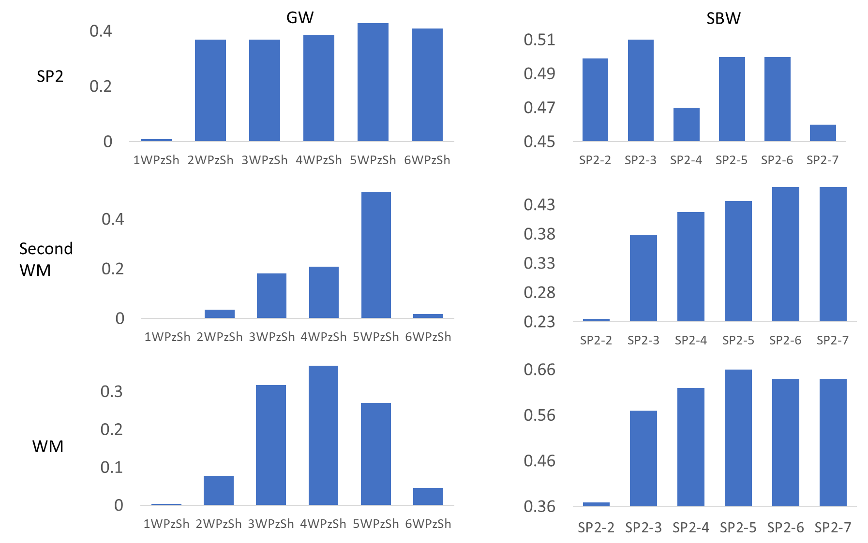
Figure S7: Bar graphs showing the R-squared (R²) values from linear regression analyses. These analyses compared the measurements of all compounds between two locations. R² is for linear accepted plotting subsurface sources (top to bottom): SP2, Second WM (WM1), WM (WM2) against each measurement in groundwater (left column) and subsurface water (right column). The closest in time and distance the measurement, the higher R² are. For example: lowest R² was accepted for Second WM against 1st data in groundwater time series. Highest R² (0.66) was accepted for WM against SP2 4th sample in the time series. Highest values stand for SP2 series against WM (right bottom). WM was taken from manhole (subsurface related) at the last day of subsurface time series (sample SP2-7), 128 m from pipe outlet. This supports the groundwater and subsurface water to be distinct flowpaths.

C.2 patterns in groundwater and subsurface time series
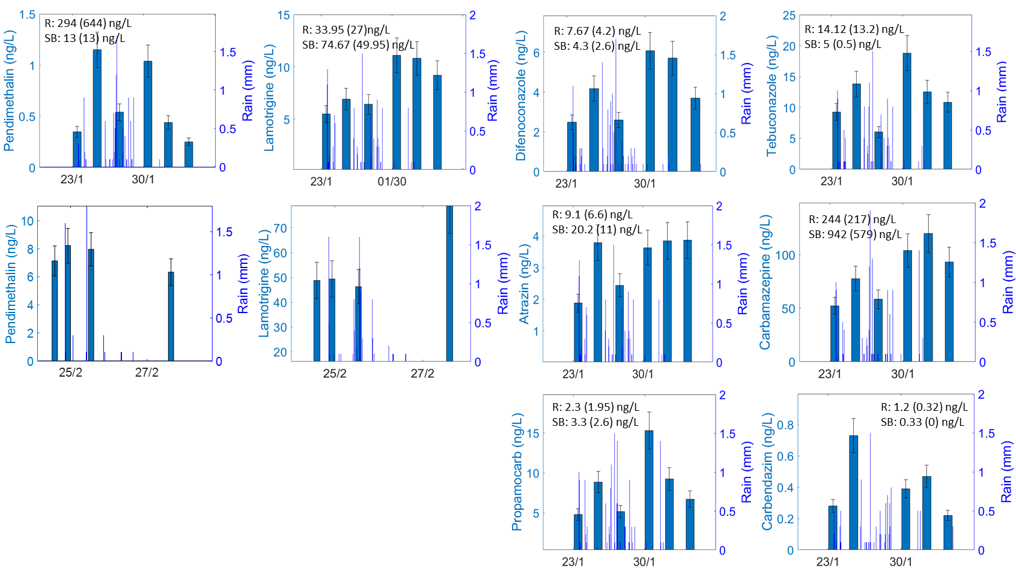
Figure S8: Time series of several 1st group compounds detected in groundwater in the West shallow piezometer (23 Jan-3 Feb 2022). Lamotrigine and pendimethalin include also subsurface time series (22-27 Feb 2022) having a similar pattern. Concentrations are given in dark blue bars, rain is shown as thin lines. Typical behavior is observed in this group: the concentration increases with storm beginning, then dilutes in storm peak and afterwards concentrations rise. Average subsurface (SB) and runoff (R) concentration over 1st and 2nd storms for each material is provided, with standard deviation in parenthesis.
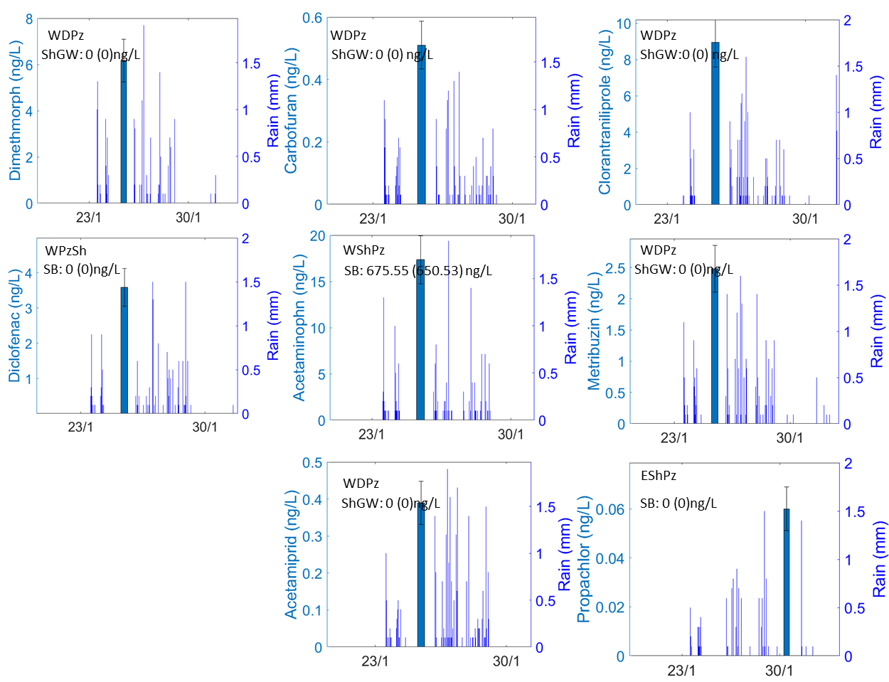
Figure S9: Second group: Legacy pollutants appeared in storm. Most compounds were not detected in the upper layers. Concentrations are given in dark blue bars, rain is given in thin lines. The compounds were detected in deep groundwater of the West field (WDPz), shallow West field piezometer (WShPz) or shallow East field piezometer (EShPz) during the storm. Propachlor was detected in the last days of the storm. SB is the average subsurface concentration. Standard deviation appears in parenthesis.

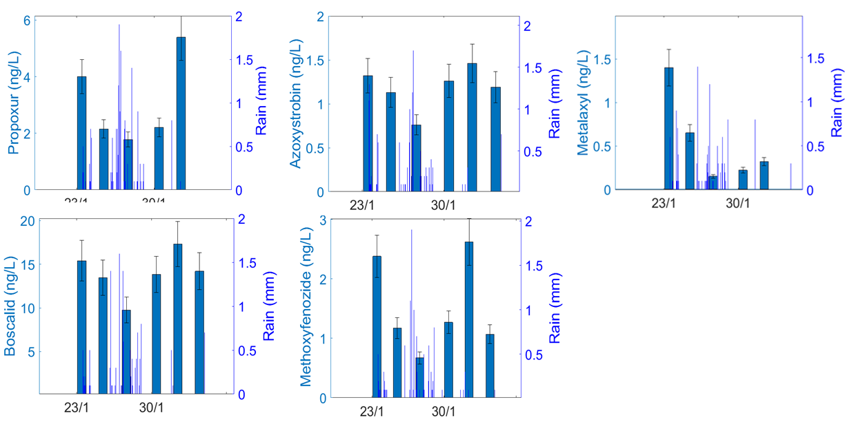
Figure S10: Third group: chemical concentrations decrease gradually with storm due to dilution in groundwater (Jan. 2022). Concentrations are given in dark blue bars, rain is given in thin lines. Concentration rise occurred immediately after the storm peak, presumably due to new water. 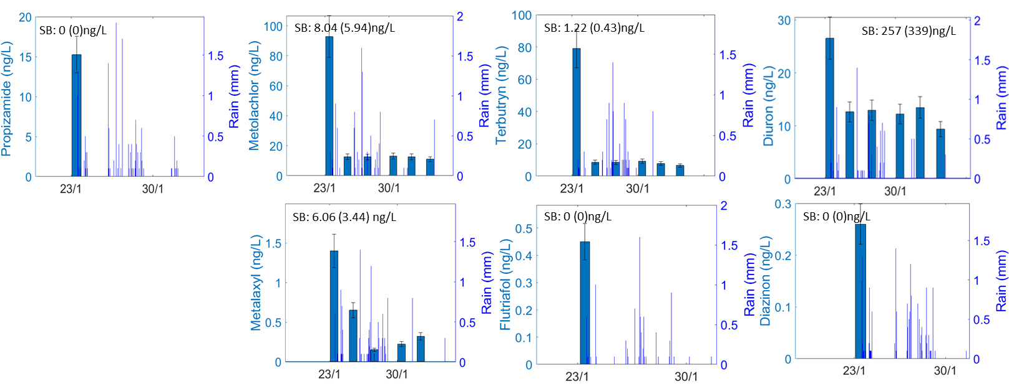
Figure S11: Fourth group: Strong dilution of West field groundwater in a storm due to low concentration in upper layers and negligible concentration in soil water, leading to insignificant concentration rise by a piston effect. For some compounds, the dilution reduced the concentration below the detection limit. After storm peak, and presumably due to deficiency in the SB (subsurface) for most compounds or very low mobility, water arrival with a lower concentration than groundwater causes dilution for water during the entire storm.
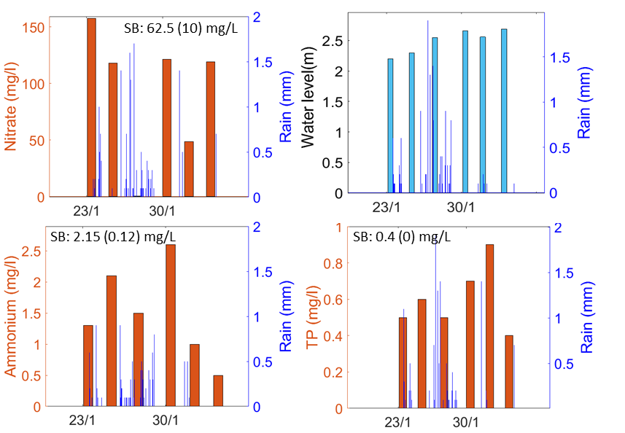
Figure S12: Nutrients (nitrate, ammonium and total phosphorus (total P) measured in the West shallow piezometer. The nitrate and the total P are characteristic nutrients, representing mobile and less mobile molecules, respectively. The nitrate behaves similar to the 3rd group, and the total P behaves like compounds presumably related to soil water and adsorption-desorption processes.

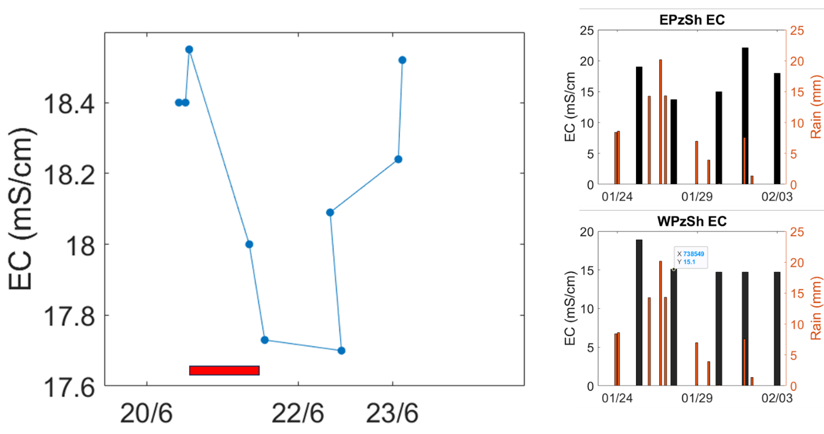
Figure S13: EC decline in irrigation, similar to solute organic pollutants. The red bar is the irrigation duration: 24 hours since 20/6 at 9:00 AM. EC in the East shallow piezometer (up) and West shallow piezometers demonstrate the dilution with the water. In the West piezometer solutes are likely rare at the upper level.
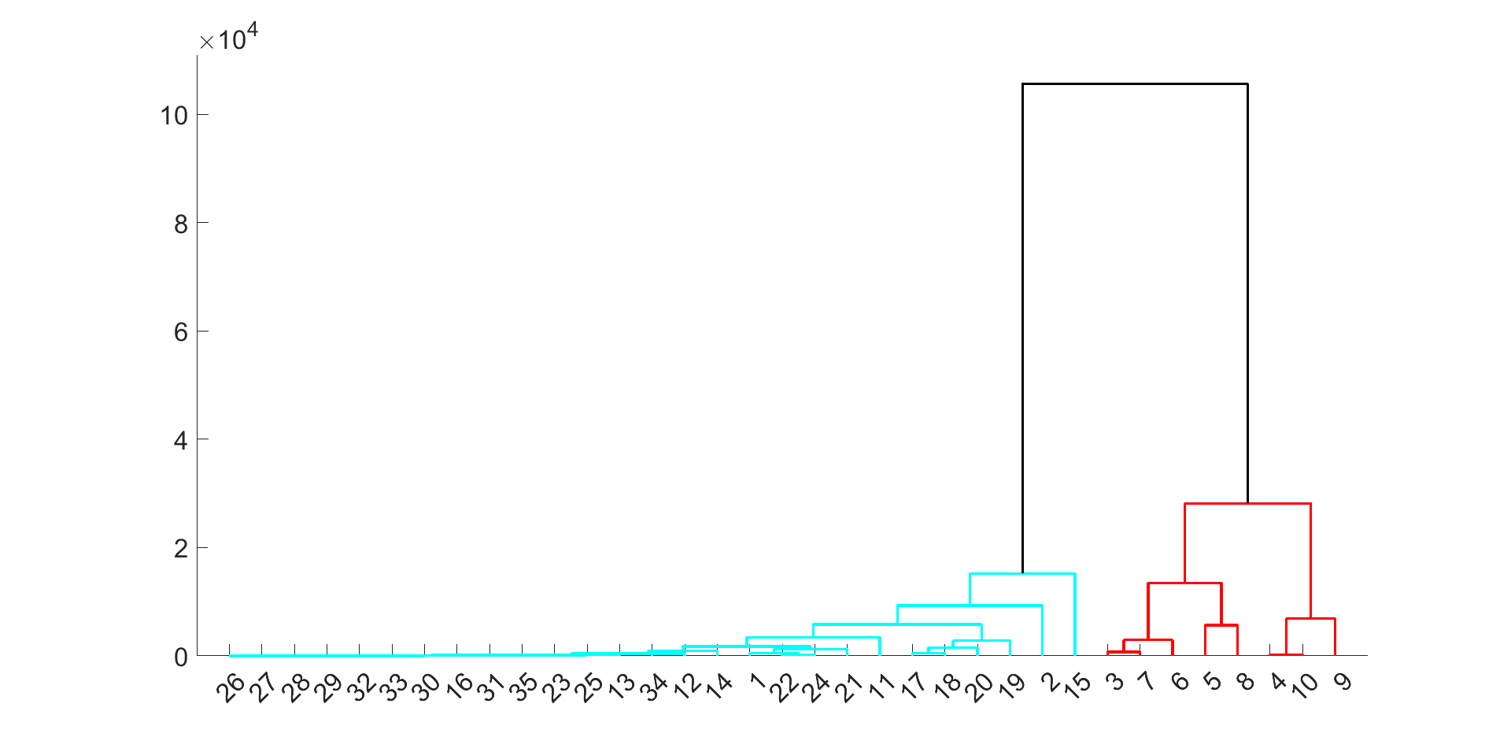
Figure S14: Dendrogram for all field samples indicate the clear separation of the East runoff samples from all other samples. East groundwater samples have similar composition to West field samples (24, 25).

Appendix D- Research data
EXCEL- double click on the EXCEL to open data:

